xSVKM’S NMIMS Deemed-to-be-University Mukesh Patel School of Technology Management & Engineering Department of Computer Engineering

Course Code |  | Program | B Tech
Semester | V | Year | III
Name of the Faculty | Prachi Natu | Class
Course Title | Data Mining | Academic Year | 2020-21

LAB

Manual

PART
A

(PART A : TO BE REFFERED BY
STUDENTS)

Experiment
No.07

A.1

Aim:

To study and implement K-means Clustering Algorithm.

A.2
Prerequisite:

Refer the Lab manual for the steps and any programming language.

A.3
Outcome:

After successful completion of this experiment students will be able to

- To understand the concept of Data Mining by implementing some data mining algorithm.

- To understand the clustering and types of clustering.

- To understand how to create clusters by K-means algorithm.

A.4 Theory

What is Cluster?

Cluster is a group of objects that belong to the same class. In other words the similar object are grouped in one cluster and dissimilar are grouped in other cluster.

What is Clustering?

Clustering is the process of making group of abstract objects into classes of similar objects. Points to Remember
SVKM’S NMIMS Deemed-to-be-University Mukesh Patel School of Technology Management & Engineering Department of Computer Engineering

Course Code | BTICO09003 | Program | BTICO09003
Semester | IX | Year | IV
Name of the Faculty | Artika Singh | Class
Course Title | Data Warehouse and Mining | Academic Year | 2019-20

- A cluster of data objects can be treated as a one group.

- While doing the cluster analysis, we first partition the set of data into groups based on data similarity and then assign the label to the groups.

- The main advantage of Clustering over classification is that, it is adaptable to changes and help single out useful features that distinguished different groups.

Applications of Cluster Analysis

- Clustering Analysis is broadly used in many applications such as market research, pattern recognition, data analysis, and image processing.

- Clustering can also help marketers discover distinct groups in their customer basis. And they can characterize their customer groups based on purchasing patterns.

- In field of biology it can be used to derive plant and animal taxonomies, categorize genes with similar functionality and gain insight into structures inherent in populations.

- Clustering also helps in identification of areas of similar land use in an earth observation database. It also helps in the identification of groups of houses in a city according house type, value, and geographic location.

- Clustering also helps in classifying documents on the web for information discovery.

- Clustering is also used in outlier detection applications such as detection of credit card fraud.

- As a data mining function Cluster Analysis serve as a tool to gain insight into the distribution of data to observe characteristics of each cluster.

Clustering Problem

- Given a database D={t1,t2,…,tn} of tuples and an integer value k, the Clustering Problem is to define a mapping f:Dg{1,..,k} where each ti is assigned to one cluster Kj, 1<=j<=k.
- A Cluster, Kj, contains precisely those tuples mapped to it.

Types of Clustering

Hierarchical – Nested set of clusters created.

Partitional – One set of clusters created.

Incremental – Each element handled one at a time.

Simultaneous – All elements handled together.

Overlapping/Non-overlapping

Partitional Clustering
- Nonhierarchical
SVKM’S NMIMS Deemed-to-be-University Mukesh Patel School of Technology Management & Engineering Department of Computer Engineering

Course Code | BTICO09003 | Program | BTICO09003
Semester | IX | Year | IV
Name of the Faculty | Artika Singh | Class
Course Title | Data Warehouse and Mining | Academic Year | 2019-20

- Creates clusters in one step as opposed to several steps.

- Since only one set of clusters is output, the user normally has to input the desired number of clusters, k.

- Usually deals with static sets.

K-Means Clustering
Initial set of clusters randomly chosen.

Iteratively, items are moved among sets of clusters until the desired set is reached.

High degree of similarity among elements in a cluster is obtained.

Given a cluster Ki={ti1,ti2,…,tim}, the cluster mean is mi = (1/m)(ti1 + … + tim)

A.5 Procedure/Algorithm:

A.4.1 TASKS :
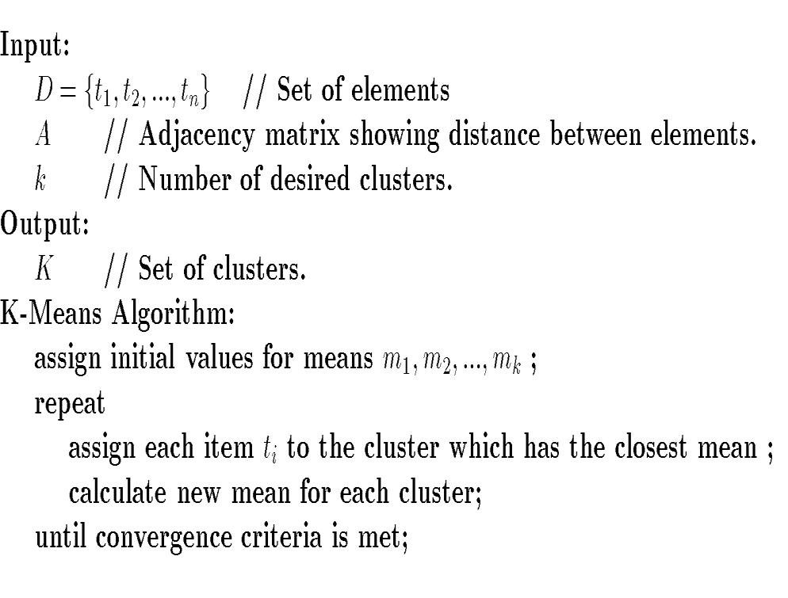
SVKM’S NMIMS Deemed-to-be-University Mukesh Patel School of Technology Management & Engineering Department of Computer Engineering

Course Code | BTICO09003 | Program | BTICO09003
Semester | IX | Year | IV
Name of the Faculty | Artika Singh | Class
Course Title | Data Warehouse and Mining | Academic Year | 2019-20

K-Means Example
- Given: {2,4,10,12,3,20,30,11,25}, k=2

- Randomly assign means: m1=3,m2=4

- K1={2,3}, K2={4,10,12,20,30,11,25}, m1=2.5,m2=16

- K1={2,3,4},K2={10,12,20,30,11,25}, m1=3,m2=18

- K1={2,3,4,10},K2={12,20,30,11,25}, m1=4.75,m2=19.6

- K1={2,3,4,10,11,12},K2={20,30,25}, m1=7,m2=25

- Stop as the clusters with these means are the same.

